Name Plate
In a Separate file you are going to create a name plate in Photoshop. You will want to use the images that reflect you Save them all in the appropriate folder. You will have a layer for each of the Letters in your name. There are several ways to approach this. You could create a clipping Mask, or you could use type masking.

- A workspace of 10.5” by 2.75” . Save in ProjectPS\Nameplate folder, call the file: LastnamefirstInitalNameplate
- A background
- A consistent font
- Add effects such as a glow or a stroke
- Add your period in the lower right hand corner (ie. Period 3)

You will need to mount each of the printouts on a piece of construction
Reflection

This is a Photoshop project that should show a reflection of yourself from a child to the young adult that you are. You are to incorporate your vast knowledge of PhotoShop to create a representation of who you are. You will need at least one picture of yourself as a child and a current picture of yourself. You will want to include things that are important to you such as hobbies or activities that you enjoy, people or things that are important, goals or ethics that your value, etc. This is not a collage, but a blended image of who you are. Be creative. Take your time and do a professional and creative job.

- Workspace is 9” by 7” Save in ProjectPS\Reflection Folder Call the file: LastnamefirstInital Reflection
- At least Two photographs of yourself
- At least 6 other images that reflect who you are.
- The use of effects, blending, feathering, image enhancements, opacity and or filters.
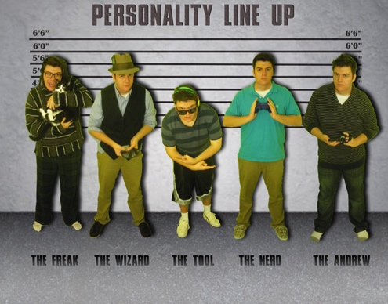
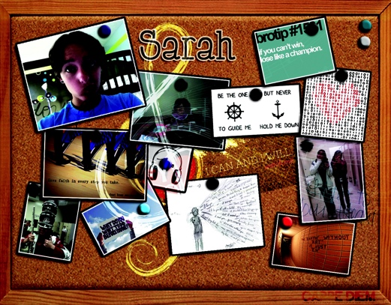
- A background image paper when completed. Make sure your name is on the back and turn in.

